Week 2 Report: Exploratory Data Analysis
Project Title: Enterprise Telco Customer Churn & Revenue Attrition Analysis
Prepared by: Senior Data Analytics Engineer
1. Executive Summary
This report presents an Exploratory Data Analysis (EDA) performed on the cleaned telecommunications dataset comprising 7,043 customer records. The objective of this phase is to evaluate baseline statistics, identify primary behavioral drivers of churn, quantify financial revenue attrition, and pinpoint high-risk customer segments to inform downstream machine learning models.
2. Summary Statistics Table
Metric Category | Overall Dataset | Retained Cohort (Churn = No) | Churned Cohort (Churn = Yes) | Impact / Variance
Customer Volume | 7,043 | 5,174 (73.46%) | 1,869 (26.54%) | 26.54% Base Churn Rate
Monthly Charges (MRR) | $456,116.60 | $316,985.75 | $139,130.85 | 30.50% Monthly Revenue Loss
Average Tenure | 32.37 Months | 37.57 Months | 17.98 Months | 52.1% lower tenure in churned group
Average Monthly Bill | $64.76 | $61.27 | $74.44 | Churned accounts pay +21.5% higher fees

3. Key Statistical Findings & Insights
- Contract Commitment Impact: Customers on Month-to-month contracts exhibit a 42.71% churn rate, compared to 11.27% for 1-Year and 2.83% for 2-Year contracts. Month-to-month subscribers represent over 88% of total churned customers.
- High-Risk Internet Service: Fiber Optic internet customers churn at 41.89% (vs. 18.96% for DSL users). This is primarily driven by high monthly charges ($74.44/mo average) without bundled support features.
- Onboarding Hazard Window: Tenure density analysis reveals that churn risk is heavily concentrated within the first 1 to 10 months of service.
- Payment Method Friction: Customers using manual Electronic Checks churn at 45.29%, whereas automated payment methods (Bank Transfer at 16.71% and Credit Card at 15.24%) demonstrate significantly higher retention.
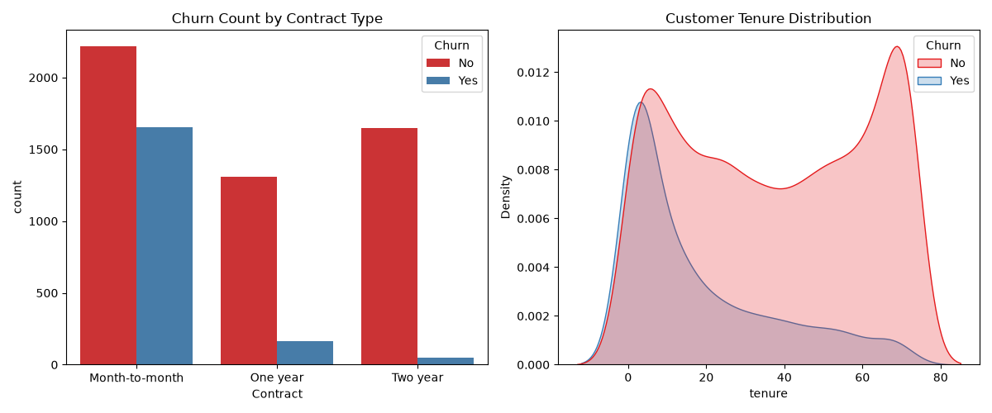
4. Visual Analysis & Evidence
- Chart 1 (Churn Count by Contract Type): Highlights the drop-off in churn counts as contract commitment length increases.
- Chart 2 (Customer Tenure Distribution): Shows a prominent density peak for churned customers during the initial onboarding window (tenure $<12$ months).
5. Actionable Recommendations for Modeling (Week 3)
- Target Feature Inclusion: Contract type, payment method, tenure, and internet service tier must serve as core predictors in classification models.
- Handling Class Imbalance: Address the 73:27 class imbalance during model training using class-weight balancing to ensure high recall for high-risk accounts.

